**Kaeser Kompressoren**

**Established in 1919 as a mechanical engineering workshop, Kaeser Kompressoren is a family-owned business and today is one of the world's leading compressor manufacturers and compressed air systems providers.** **Kaeser's production centres are located in Coburg (main plant), Göttingen and Gera, Germany. The company approximately 7500 employees worldwide.**

Kaeser's comprehensive product range comprises stationary and portable rotary screw compressors, stationary and mobile reciprocating compressors, vacuum pumps, rotary blowers, rotary screw blowers, turbo blowers, filters, dryers, air tools and accessories. Furthermore, Kaeser's state-of-the-art compressor control systems with advanced IT technology take compressed air efficiency to the next level and beyond. Both users and the environment therefore benefit from the consequent energy-savings.

Subsidiaries and authorised partners in over 140 countries ensure that users are able to enjoy all of the benefits that the very best in compressed air engineering has to offer. Key markets include the EU, the United States, Latin America and the Asia-Pacific region. Kaeser owes its enviable reputation not only to the exceptional efficiency and quality of its products, but also to its reliable field service. More recently, the other industry-leading services offered by the company - such as operator models for compressed air stations, concepts within the framework of Industry 4.0 and predictive maintenance - have increasingly moved to centre stage.

Kaeser's many years of strong growth and expansion are directly attributable to its passion for innovation and strict quality standards. Both are driven by the hard work and dedication of its employees, whose expertise, combined with ongoing professional development, keep them attuned to the very latest technology. The company's opening-up of key global markets in recent years has also created many additional jobs and secured existing ones, both in Germany and around the world.

The company is headed by Thomas Kaeser, Dipl.-Wirtsch.-Ing, grandson of the company's founder, and Tina-Maria Vlantoussi-Kaeser, Dipl.-Wirtsch.-Ing.

******

**Brief company history:**

**Founded:** Coburg 1919

**Trade name:** Kaeser Kompressoren

**Founder:** Carl Kaeser senior

**Executive management:** Thomas Kaeser, Dipl.-Wirtsch.-Ing.,   
Tina Maria Vlantoussi-Kaeser, Dipl.-Wirtsch.-Ing.

**Products:** Reciprocating and rotary screw compressors ranging from 0.18 to 515 kW, portable rotary screw compressors, high-pressure and dry-running compressors, compressor control systems, vacuum pumps, rotary blowers, rotary screw blowers, turbo blowers, air filters and tools, refrigeration & desiccant dryers, as well as compressed air system accessories and services.

**Turnover (Kaeser Kompressoren SE): EUR 1.2 billion (2021)**

**Employees:**

**Worldwide:** approximately 7500

**Apprentices:** Approx. 300

**Apprentice positions per year (since 2016):** 120

**Production centres:** Coburg (main plant), Göttingen, Gera

**Branch offices:** 8 regional offices throughout Germany

**Worldwide sales partners:** Represented in over 140 countries by Kaeser-own branch offices and exclusive authorised partners

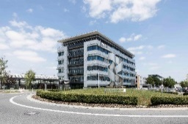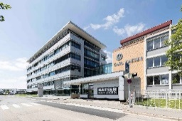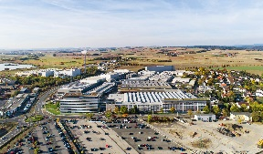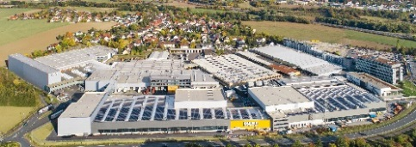

Kaeser Kompressoren’s headquarters and main plant in Coburg-Bertelsdorf, partial view from the west, with the distribution centre and fully automated high rack warehouse (far left).

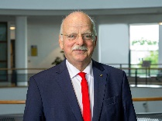

Tina-Maria Vlantoussi-Kaeser, Thomas Kaeser